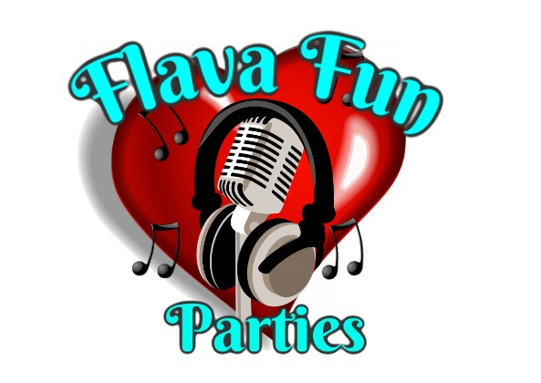

**Flava Fun Parties**

Risk Assessment

**Equipment setup installation**

| Potential Hazard | Who's at risk | Risk Level | Evaluation and control measures |
| --- | --- | --- | --- |
| Manual handling | DJ | low | All items used, Including Speakers are of a single person lift. (Less than 25kg) trolley to be used for moving equipment over a distance. Members of the public not allowed to move any equipment |
| Cable Hazards | DJ | low | Try to not have a Public present during setup. Cable runs past doorways to be concealed in rubber floor stripping before guests arrive. DJ Booth to be cited as close as possible to a powered wall socket, to reduce the need for trailing leads. The Dj area is for only staff and all leads will be kept behind the DJ stand and equipment. |
| Objects falling from heights | DJ | low | Equipment inspected before each use to ensure mounting points are safe/secure. All lighting fixtures over 5kgs to be installed with lighting safety cable in addition to the usual mounting method. Speaker tripods to be placed against walls or in corners, away from footfall. Speakers to be fitted securely to correctly rated tripods, securing screws and locking pins must be used. |
| Hearing damage from high volume levels during sound checks | DJ | low | Keep exposure to high volumes to a minimum. Short periods of exposure to determine safe volume levels |
| Working at heights | DJ | low | Use provided steps to access stages. Set back the DJ booth at least 600mm from the edge of the stage to allow access in front, reducing the risk of falling off the stage. When setting up high level backdrops, Buddy system is in place so 1 person holds the ladder while the DJ is on the ladder. If there is no access to the stage our staff will not set up on the stage and will set up in an appropriate space. |

**During Events**

| Hazard | Who is at risk | Risk level | Measures |
| --- | --- | --- | --- |
| Cable hazard | DJ, Guests, Venue staff | low | Cable runs past doorways to be concealed in rubber floor stripping. DJ Booth to be cited as close as possible to a powered wall socket, to reduce the need for trailing leads. Speaker/power cables to be wrapped and concealed if they extend beyond the DJ booth footprint All other cables to be concealed within the confines of the DJ booth footprint. Public are not allowed behind the DJ booth or in the DJ booth area |
| Electrocution from equipment | DJ guest and venue staff | low | All Equipment visually inspected during setup. All mains powered equipment tested annually and faulty items replaced. All DJ Equipment items are individually fused to the correct rating and Collectively ALL equipment is protected through a Plug-in Residual Circuit device. |
| Objects falling from heights | DJ guests and venue staff | low | Speakers to be fitted securely to correctly rated tripods, securing screws and pins must be used. Tripods are set back as much as possible and covered too bright for guests to see to avoid knocking into the stands,if possible put up against a wall or in a corner. All lighting fixtures over 5kgs installed with lighting safety cables in addition to the usual mounting method. All overhead lighting is within the DJ booth footprint. |
| Hazards from floor standing equipment | DJ guests and venue staff | low | Equipment Stands to be set up in corners or against a wall as much as possible, if this isn't possible trying to keep the speakers and lighting stands away from footfall. Also staff are constantly on guard to try and keep footfall away from equipment. |
| Hazard from high volume levels | DJ guests and venue staff | low | Constant sound level monitoring by the DJ with walks around the venue to determine required volume. Keeping high music volume exposure to a minimum. Our staff will also ask any bookies or staff present to keep the DJ and staff informed if music levels get too loud for any children’s parties or events. |
| Hazard from prolonged exposure to volume levels | DJ | Moderate | Hearing protection to be worn at Every high volume event. |
| Epilepsy induced by flashing lights | Guests and venue staff | low | Ask the event organiser upon booking to warn guests of flashing lights just in case any one suffers from epilepsy, if known of any of the guests suffer from epilepsy and if so change lighting programs to soft or faded if possible We DO NOT use any strobe lighting in any of our events |
| Eye damage from laser lighting | DJ staff Guests and venue staff | low | All laser lights are not pointed directly within eye line, and all lights are placed up high on stands to keep a fair distance from any eye line |
| Working at height | Dj staff Guests and venue staff | low | Guests and venue staff are not allowed on stage during performance. DJ to access stage using the steps/ staircase provided |
| Burns from Hot equipment | DJ guests and venue staff | low | We have discontinued use of all incandescent and halogen lighting fixtures. LED lighting fixtures run cool to the touch. Integral speaker amplifiers may feel warm to touch after many hours of use but never get “hot” Speakers are set against a wall or corner, so the rear amplifier section is not easily accessible to touch. |
| Slips, trips, falls on the dance floor | Dj staff guests and venue staff | low | Use the microphone to highlight any dangers on the dance floor and alert any staff members, dance floor isn’t our responsibility and is stated in our terms and conditions |
| Emergencies | DJ staff guests and venue staff | low | DJ to be aware of all fire exits and ensure all equipment is not blocking the exits. DJ to be aware of First aid box location |

**Equipment Tear - down (pack away)**

| Hazard | Who is at risk | Risk level | Measures |
| --- | --- | --- | --- |
| Manual handling injuries | DJ | low | All items used, including speakers are of single person lift. (less than 25kg). Trolly to be used for moving equipment over a distance. Members of the public are not allowed to move any equipment. |
| Hazard from cables | DJ guests and venue staff | low | Public will have left the dance floor and most will have vacated the venue once music stops, cables run past doorwars to be removed as a priority. Cables leaving the dj booth footprint to remove 2nd priority. All cabling and stands will be packed down before any the big major equipment of the DJ footprint is packed away to keep guests away from any trip hazards |
| Objects at height | DJ | low | Extra care to be taken when lowering raised equipment (speakers and lighting fixtures) |
| Working at heights | DJ | low | Use provided steps to access stages, dj to be mindful or stage edge during tear down. Buddy system in place so 1 person holds the ladder while the DJ is on the ladder. |