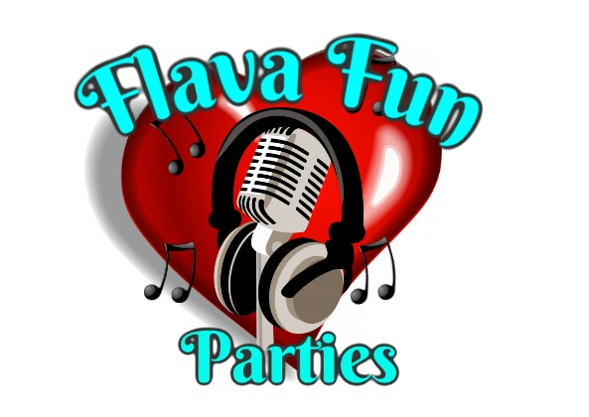

Risk assessment for None stop kids sessions

| Hazard | Who's at risk | Risk level | Notes |
| --- | --- | --- | --- |
| Minor injuries  • Slips  • Trips  • Stumbles | Children  staff | high | First aider is always on site to respond to any minor injuries. Staff supervision is arranged by the activity leader to ensure children are suitably managed and kept safe. |
| Major Injuries  • Broken bones  • Concussion | Children | medium | First aiders are always on site to respond to any injuries and are competent in dealing with emergency situations, all relevant precautions will be in place to try and stop any hazards forming. All staff will be on constant supervision and watch and all children will be monitored continuously whilst using equipment |
| Collisions with other participants | Children  staff | high | First aiders are always on site to respond to any minor injuries and staff supervision is arranged by the activity leader to ensure children are suitably managed and kept safe. Staff will also ensure there is enough space for all children to play appropriately. |
| Equipment  Faulty / misuse / slips and trips | Children  staff | medium | All equipment will be checked and assessed before it is used, all equipment is well maintained and in good working order. All equipment is stored safety and out of the way during the games and activities to reduce children slipping or tripping and falling. All staff members are aware of one manual handling policy to ensure they are not lifting heavy equipment independently. |
| Playing surface (hall, field, astro) | Children | medium | Playing areas / surfaces and pitches are checked before activities. This will reduce the risk of slips and trips, The activity leader will also ensure there is enough space for all children to play appropriately |
| Children’s behaviour | children | medium | Children are reminded of the safety instructions before the activity starts, appropriate staff to child ratios dependant on numbers of participants, children are also reminded of the rules to ensure they behave throughout the entire session. Any inappropriate behaviour will be dealt with accordingly - see behaviour policy. Removal of children from the activities will occur if necessary. |
| Being hit by a moving object  Bat Ball etc | Children  staff | high | First aiders are always on site to respond to any minor injuries or emergency situations, with a full stocked first aid kit.  The activity leader will also ensure there is enough space for all children to play appropriately. Ball games or bat games will be kept at a safe distance from other activities going on, All children will be briefed before taking part and given rules around the use of the equipment. Staff will be supervising at all times. |
| Being hit by a foam dart or object | Children  staff | medium | Children are briefed on the safety instructions and rules before sessions commences and throughout. Children are to only aim at the targets provided and reminded never throw or point a gun at other people. Once all participants have used the amount of objects to complete the task the children are moved away from the area and the staff check the area for the equipment and put all targets backup and in place. |
| Trapped skin in activities | Children  staff | medium | Demonstrations will be given on how to use the equipment correctly and safely, children are reminded of the rules and safety instructions before sessions commences. |
| Standard of shooters | children | medium | Unavoidable - instructors to teach some basic aim shooting or throwing skills |

Signed Emma Merrick Flava fun parties owner

Date issued 05/07/23 revision date:July 2025