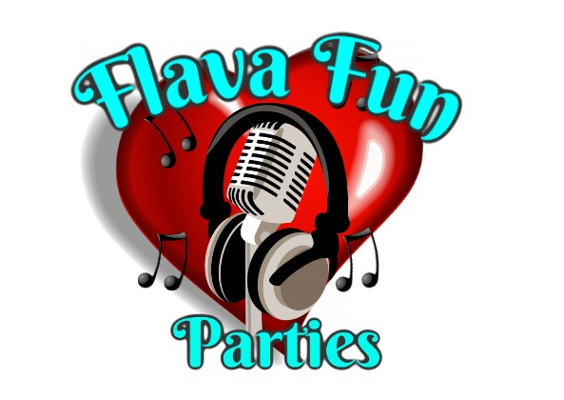

Risk assessment for flava fun parties

Bubble machine and smoke machine

| Hazard | Who is at risk | Risk level | Actions or notes |
| --- | --- | --- | --- |
| Skin irritation | Guests or children | low | We ask that children are supervised at all times whilst around the bubbles from the bubble machine or smoke from the smoke machine, Advice any reactions to rinse the area with cool water after they have finished |
| Falling on slippery surfaces | Staff and public | medium | Do not put bubbles on any surface which may become slippery when soapy water is spilt on it, bubbles and snow are best suited to grass , carpeted, gravel surfaces. Organisers must provide a safe, none slippery place for this activity to take place. All fluids for the smoke machine, bubble machine, or snow machine are kept out of the way of the guests and young children. |
| Electrocution | Staff and public | medium | Do not do this activity near electrical equipment, keep these items at a safe distance, as these can be a wet activity. All machines that are used to produce the bubbles snow and smoke are kept at a safe distances from the public, and at safe height so that children dont have easy access to the equipment, all equipment must be manned by a member of staff at all times whilst in use.All staff are trained to use the equipment. |
| Eye stinging and irritation | Mostly children | low | All children are asked to be supervised by a adult whilst taking part in this activity, If any irritation to eyes or skin happens people are advised to rinse with cool clean water to wash away all irritations |
| Choking on foam, smoke or breathing difficulties | Staff and public | Low | Organisers are advised to provide water at no charge if any of these should occur, also there should be a first aider present to aid with any health issues that may arise. |
| Burns | Staff only | low | Use caution when working with hot water or the fluids that produce the effects, all staff are trained to use the equipment and only staff are allowed to man the equipment to eliminate any chance of burns or irritations. |
| Smoke or haze fluid causing irritations | Staff | Low | Staff are advised to wear gloves when working with the fluids for the equipment. Any spillages should be mopped up immediately. |
| Damage to clothing and possessions | Staff and public | low | Staff understand and accept responsibility for damage to their clothing and possessions, when working with the snow bubble or smoke machines. Staff to inform the public of the risk and cover any items or remove any items they don't want effected |
| Lifting of the equipment | staff | low | Operators and staff must use the correct lifting procedures, and also setting up must be kept at a distance from any public that may be around, the organiser must provide an area that is kept clear for staff to safely set up and pack away equipment. |