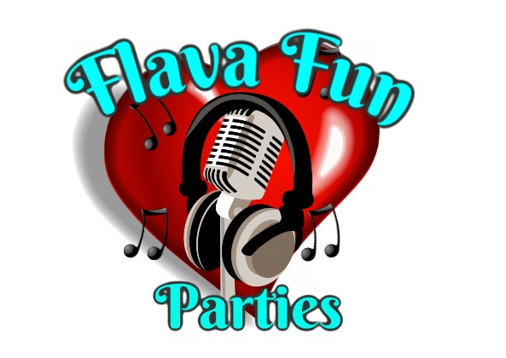

Flava fun parties

Risk assessment for Hair station

| Hazard | Who is at risk | Risk level | Actions |
| --- | --- | --- | --- |
| Falling off the chair | Children that squirm or move around alot | low | Staff will advise all children that they must sit still for the duration of the service, and keep their head in place and still whilst our staff work. Any children that can not sit still enough will be asked to choose a different service that is quicker. |
| Scissors near the head and hair | Children or guests | low | Staff have to use scissors to cut threads, they will never cut the hair or have any sharp scissors near the face or head of the client. All sharp tools will be put out of the way on the hair station’s work area which spectators are asked to keep out of the way of |
| Spike pool tools | Children and guests | low | These spike tools and clamps are used to put tinsel in hair, these do go near the scalp but staff warn the client to sit as still as possible for a few seconds so that this part of the process can happen and no client is hurt in the process |
| Hair bands (elasticated) | Children and guests | low | All products used are of EU standard and quality products, the hair bands that are used to keep the hair up into place could snap and ping off the head, our staff can’t foresee this happening and if this does happen this shouldnt cause any harm to staff or clients |
| Beads and hair jewels | Children or guests | low | The beads that are used are tied into the hair with wool which is easily removable by opening the knotted wool at the bottom and releasing the beads, the beads are plastic or wooden, and securely held into place. Our Jewels are circular motion screwed into the hair to hold in place, these are loose fitted and can easily become tangled into the hair, staff do advise the client at the time that this can happen before purchase and also how to take the jewel out of the hair. |
| Wool and threads | Children and guests | low | Wool is wrapped around strands of hair in a circular motion to create a colourful thick strand. This is finished off with beads at the bottom and tied to secure in place, all clients are advised of how to take the product out of the hair painless and harmless, where the hair will not be damaged at all. |
| Hair tinsel | Children or guests | low | Hair tinsel is squeezed into place 5 mm away from the hair root, this should not damage the hair root in any circumstances, and can be removed by rubbing the area between the fingers to loosen the grip and release the tinsel from the hair. |
| Hair chalks | Children and guests | Medium | High quality hair chalks are used to temporary colour children’s hair, all our products are eu regulated products and standard. Hair chalks should wash out very easily with normal every day shampoo, in the event of any temporary dying of the hair the client is advised that this may happen and to rewash the hair with a stronger shampoo to help shift the discolouration. |
| Hair glitter | Children and guests | low | High quality glitters for skin are used, these are attached to the hairline and scalp by hair gel to fix into place, this is advised to be removed by washing the hair and scalp with normal shampoo this may take a couple of attempts if fine glitter has been used. |
| Hair tension or pulling | Children or guests | low | All our services are provided with the lowest risk to the hair of the guest or child, if there's any client that experiences hair tension or pulling from the products they are advised to seek the staff for removal. |