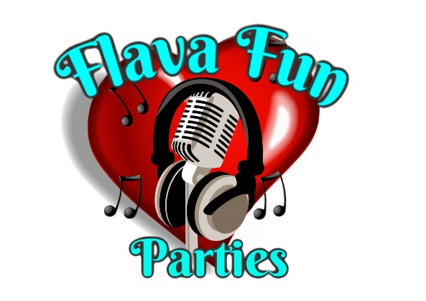

**Risk assessment for flava fun parties - Movie Sessions**

| Hazard | Who's at risk | Risk level | Notes |
| --- | --- | --- | --- |
| Equipment • Equipment failure • Screen deflating • Volume of speakers | Children  Guests  staff | low | Conduct regular equipment checks prior to the start of sessions.  • Check for worn or faulty equipment  • Supply all equipment in a clean and serviceable condition  • Check equipment before use  • Provide specific training in and awareness of safety requirements.  • Volume check at closest seated area |
| Physical  • Noise level of audio • Cramps  • Exhaustion and fatigue | Children  Guests  staff | low | Ensure the suitability and competency of students participating in the activity  • Constantly monitor students for fatigue and exhaustion  • Set a distance of no closer than 10 metres to speakers which generate audio.  Movie night instructor to set audio to a level which is not excessive and could damage participants' hearing. |
| Physical  Mats and throws  Wires | Children  Staff  guests | low | All children taking part in the session will be made aware of the chance of slips or falls on matting and throws, the children will be asked to sit in their designated areas and use judgement when getting up. Any misuse of the mats throws and cushions will result in the child being removed for the safety of the other children.  All wiring will be kept out of the way of any footfall and this will be guarded by members of staff to make sure the areas where equipment are kept will be kept clear of children and guests |
| Students  • Special needs  • High risk behaviours  • Medical conditions  • Student numbers  • Child protection | Children | low | Obtain parental permission including relevant medical information  • When students with medical conditions are involved, ensure that relevant medical/ emergency plans and medications are readily available (insulin, Ventolin, Epipen, etc)  • Refer to individual education plan/Educational adjustment plan/Behaviour management plan and other student documents.  • Ensure there is adequate adult supervision  • Participants briefed on activity boundaries, correct radio protocols and contingency procedures in the event of external interference during activity  • Activity utilises frequencies with minimal radio traffic  • Roaming supervising Staff supplied with radios monitor movements of groups on site  • Jewellery can be a serious hazard when undertaking many activities. |
| Injury from slip/ trip, caused by:  • Spilled food/ drink on floor  • Wet floor after mopping | Children  Guests  staff | low | ●Wet floor signs used to indicate wet areas.  ●Staff to clear up quickly.  ●Pupils supervised to travel quickly and safely, directly to their seats, to minimise travel time and likelihood of spilling food - lunchtime supervisors to implement this.  ●Designated staff to supervise clearing/ cleaning plates to avoid food spilling over onto the floor. |
| Injury from slip/ trip, caused by:  • Collision with furniture i.e. tables, benches, lunchbox trolleys,  • Coats/ bags/ lunch boxes on the floors | Children  Guests  staff | Medium | • Children encouraged to walk not run –lunchtime supervisors to implement this.  • Furniture stored out of way of walkways, doors etc, to minimise risk of collision.  • Coats stored neatly designated areas when children are eating lunch –lunchtime supervisors to implement this.  • Bags and lunch boxes kept on trolleys when not being used – lunchtime supervisors to implement this. |
| Injury caused by children colliding with other people | Children  Staff  guests | medium | • Children are asked to walk not run –lunchtime supervisors to implement this. |
| Injury during a building evacuation (e.g. fire alarm):  • Collision  • Slip/ trip  • Panic | Children  Guests  staff | medium | • Fire exits unobstructed by furniture, curtains, coats and bags etc, at all times.  • Lunchtime supervisors trained in their roles as fire marshals and familiar with evacuation procedures. • Children will be talked through safety precautions before the event starts for health and safety |
| Injury caused by ingestion of bacteria (germs) due to unclean surfaces/ cutlery dropped on floors etc. | Children | low/medium | • Lunchtime supervisors to be vigilant and prevent use of dirty cutlery etc. |
| Injury caused to unsupervised children - for example by slips/ trips on wet floorespecially at the end of lunchtime when most children have gone outside and catering staff have mopped the floor. The risk of injury is increased if children are left unsupervised. There is a greater risk of injuries compounded by lack of swift first aid treatment, if children are left unsupervised. | Children | low/medium | • Lunchtime supervisors remain in hall at all times during food,  • all staff will monitor the children and if any child has to leave the room the staff will be in place to monitor their movements for health and safety |
| Chocking hazards or illegic reactions | children | low/medium | All parents/guardians are asked of allergies and intolerances of the children prior to any food, this will be monitored during meal times, also any children that need medical emergancy treatment ie eppie pen then this must be left with the child on arrival. A member of staff that is first aid trained will be present at all times |

Signed by: Flava fun parties Emma Merrick Owner

Dated: 05/07/23 Revision of the risk assessment: July 2025