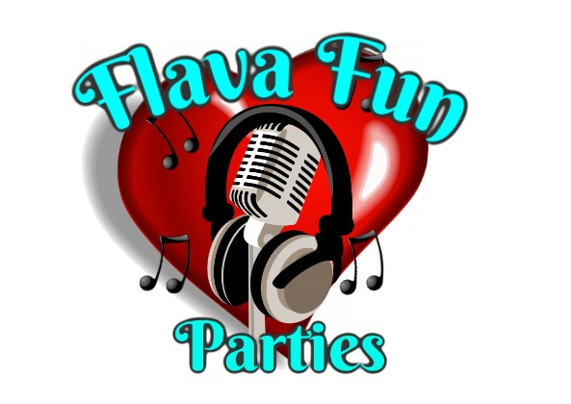

Flava fun parties

Risk assessment for Glitter station

| Hazard | Who is at risk | Action needed | Notes |
| --- | --- | --- | --- |
| Adverse skin reaction due to face paint or glitter tattoo material | Children or adults | Use approved paints, glitters, glues, adhesives. Do not paint children under the age of 3, with sensitive skin (offer to paint hand / arm instead). Advise people who appear to have skin conditions | All products used by flava fun parties are industry standard and of high quality. |
| Poking of sensitive areas | Children that squirm or move around alot | Our staff will not partake in any child that can not sit still or does not want to be tattooed or painted. |  |
| Spreading infections (eg cold sores, chicken pox, conjunctivitis) | Children and adults | Do not paint or tattoo infected areas, keep all implements clean and sanitised, use clean equipment on every person, regularly change waters, stencils or brushes and sponges. |  |
| Aggravating existing skin conditions | Children and adults | Do not paint or tattoo children or adults with sensitive skin conditions (ie eczema, open cuts or sores, or other skin conditions) | Offer to paint other areas of the body. |
| Falling off the chair | Young children | Assist the child on and off the chair. |  |
| Implements poking the client if the staff member is knocked | Children or adults | Keep a distance between spectators and waiting clients and from the station | Organisers must provide the glitter station face painter and hair station with uncrowded areas to set up with enough room for spectators to be at a distance |
| Falling or tripping over equipment | Spectators and staff | Keep work area tidy and clear space round the working area, keep spectators back a good distance whilst the staff are working on other guests, make any equipment as visible to the guests as to avoid any accidents | Organisers must provide the staff with enough space to set up and also allow for crowding of spectators and people waiting as to not crowd the staff area of work |