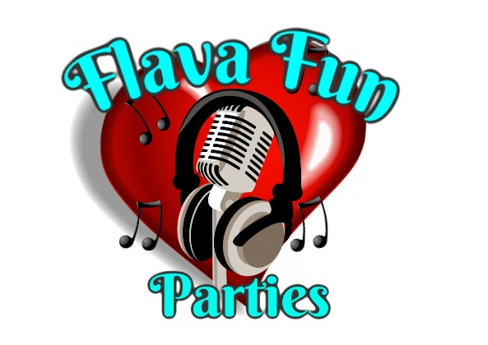

**Risk Assessment for Flava fun parties**

* **All stages of this risk assessment is for face painting a glitter station whether this is referred to as face painting/ staff / operators etc.**

| **Risk** | **Who is at Risk** | **Evaluation and control measures** | **Notes** |
| --- | --- | --- | --- |
| Adverse skin reactions due to applying face paint materials, such as allergies | Children and adults | Use approved paints and materials. Do not face paint children under the age of three/with sensitive skin (offer to paint hands or arms instead) Advise people who appear to have skin conditions.  In the event of a reaction, the face paint must be washed off immediately and a note taken of the colours used for the face paint design, so this information may be given to the parent/guardian, and the face painter can make immediate changes to which paint to use. | Flava fun parties only use face paint that is industrial standard and uk marked for sale in the uk. Our insurance may be invalid if painting any child under the age of 3 years old. |
| Paint Brush to the eye | Children who can not sit still or adults that are distracted | Advise the child or adult to sit as still as possible or this will keep happening, if they can not do as instructed then finish up at that point and send them on there way | Offer a different area of the body which is away from eyes |
| Spreading skin infections | Children and adults | Do not paint the infected area, keep painting implements clean and sanitised, use clean sponges for each person, regularly change water, thoroughly clean brushes, sponges, bowls after each event | n/a |
| Aggravating existing skin conditions | Children and adults | Be open and ask if the client has any skin conditions we should know about, be careful where we paint and offer alternative areas if necessary. Avoid any open cuts or sores | Offer an alternative area to paint |
| Falling off the chair | Young children or adults | Assist the person on to the chair and offer help getting off the chair. | n/a |
| Falling and tripping over equipment | Spectators and staff | Keep work area as clean as possible, try to keep cueing in straight lines and away from the products and the tables where staff are working, to avoid tripping on the gazebo lines using markers on the lines to make them as visible as possible for people to see. | We ask that organisers try to set in place areas large enough for the crowds that face painting attracts and allows room for the spectators. |
| Paint on clothing | Children and adults | Children advised to stay still while having their face painted . Water based paints are used for easy wash out from some materials | Staining may be a risk with some materials and depending on the method of the wash. |
| Staining of the skin | Children and adults | People will be advised to use certain products to remove the paint from the face and there are a few colours that can leave a stain, those colours are advised to be taken off with olive oil or baby wipes and not to be left on the skin for more than a couple of hours to reduce the chance of staining | Certain colours may stain the skin but we leave out signs that advise what products to use to remove face paint and any staining |
| Hair brush tangled | Children and adults | Any person in the chair are advised to stay still whilst they are being attended to by our staff, brushes and tools may get tangled in the hair which will be carefully removed in as quickly as possible with less damage to the hair as possible | Staff will always watch for hazards with customers and ask for children to sit as still as possible, they will also talk the client through the procedure to make sure they are aware of what is happening. |
| Hair tinsel attached to the scalp | Children and adults | Customers are talked through and advised to sit as still as possible, they are clamped into the hair with pliers | Hair tinsel is attached via clamping and staff will always try to attach the beading a few milimeters away from the scalp for comfort |
| Hair beads and charms | Children and adults | These are attached to the hair with either clamping or twisted into the hair | These can be prized apart and the hair charms can be twisted easily out of the hair. These are temporary hair attachments |
| Hair gel and glitter | Children and adults | These are applied to the parting of the hair and the hair line. And glitter is applied to the top of the gel to be able to stick to the hair | This can easily be washed out with water and shampoo |
| Hair wraps and plaits | Children and adults | These are attached to the hair with weaving into the hair and attaching with elasticated bands and beads for effect | These can easily be removed by unplaiting of the hair or untying the wool to release the hair underneath |
| Staff and customers safety | Staff children and adults | Face painter to operate in a safe level environment free from any hazards as assessed by the operator on site. Users will be instructed to queue in front of the equipment in view of the painter, should any customer appear to be under the influence of alcohol/drugs to the extent where they are posing a risk to the staff or the customers, they will be asked to leave, in a firm manner and assistance will be required from the bookie to assist in the removal of the person. Children should be supervised by an adult at all times. Physical contact with the child is minimised with parents holding and lifting the children onto the chair and being present throughout. | Staff will always be watching for hazards with customers and be taking the appropriate action to see the safety of everyone present |
| User safety | Children and adults | Customers must adhere to face painters instructions at all times. Flava fun parties are not responsible for any damage to personal effects, clothing, or any items that may come into contact with face paint | Staff will be as vigilant as they possibly can be we also ask for customers to be vigilant |
| Weather | Children and adults | The equipment is not suitable for use in heavy rain/ high winds. Weather conditions are to be monitored by the staff to ensure the site and equipment remain safe | All parts of the gazebo will be used against aggressive weather conditions, and the staff will do as much as possible to make sure they can stay working to their full ability through out |

**Method Statement**

The face painter arrives at the venue with the equipment and sets up, trying to make sure that they are away from any customers and guests to keep the risk of any injury minimal. They will have a table, 2 chairs per station, also advertising banners, folders with there work in and their products set up and ready to go.

The staff will assess if their child or adult has allergies, eczema, cuts or bruises etc. and advise the appropriate way forward. For the customers that can have their faces painted or glitter station services, the staff will commence the service provided in the desired position or place wanted. The face paint and glitters that we use are used in accordance with the manufacturers recommendations. Face paint is water based and easily removed if necessary. Face painters water is changed as frequently as possible. When the booking contracted time is over, the staff will pack down with minimal risk to any customers and vacate the venue as smoothly and swiftly as possible.